**[What Is the Windows Page File, and Should You Disable It?](http://www.howtogeek.com/126430/htg-explains-what-is-the-windows-page-file-and-should-you-disable-it/" \o "What Is the Windows Page File, and Should You Disable It?)**

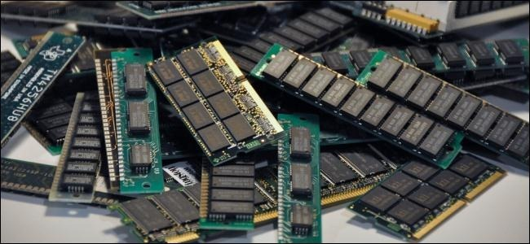

Windows uses a page file to store data that can’t be held by your computer’s random-access memory when it fills up. While you can tweak the page file settings, Windows can manage the page file fine on its own.

The Windows page file is somewhat misunderstood. People see it as the cause of slowdowns because it’s slower to use the page file than your computer’s RAM, but having a page file is better than not having one.

Image Credit: [Blake Patterson on Flickr](http://www.flickr.com/photos/blakespot/6173837649/)

http://bttrack.com/Pixel/Check/743224026?1482908786

How The Page File Works

The page file, also known as the swap file, pagefile, or paging file, is a file on your hard drive. It’s located at C:\pagefile.sys by default, but you won’t see it unless you tell Windows Explorer not to hide protected operating system files.

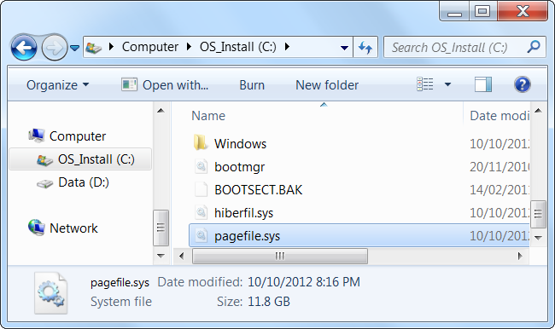

Your computer stores files, programs, and other data you’re using in your RAM (random access memory) because it’s much faster to read from RAM than it is to read from a hard drive. For example, when you open Firefox, Firefox’s program files are read from your hard drive and placed into your RAM. The computer uses the copies in RAM rather than repeatedly reading the same files from your hard drive.

Programs store the data they’re working with here. When you view a web page, the web page is downloaded and stored in your RAM. When you watch a YouTube video, the video is held in your RAM.

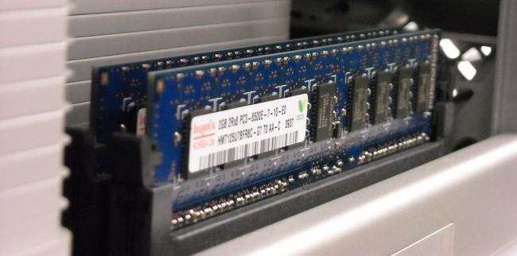

Image Credit: [Glenn Batuyong on Flickr](http://www.flickr.com/photos/glennbatuyong/4081599818/)

When your RAM becomes full, Windows moves some of the data from your RAM back to your hard drive, placing it in the page file. This file is a form of virtual memory. While writing this data to your hard disk and reading it back later is much slower than using RAM, it’s back-up memory – rather than throwing potentially important data away or having programs crash, the data is stored on your hard drive.

Windows will try to move data you aren’t using to the page file. For example, if you’ve had a program minimized for a long time and it isn’t doing anything, its data may be moved to RAM. If you maximize the program later and notice that it takes a while to come back instead of instantly snapping to life, it’s being swapped back in from your page file. You’ll see your computer’s hard disk light blinking as this happens.



Image Credit: [Honou on Flickr](http://www.flickr.com/photos/honou/4471347142/)

With enough RAM in modern computers, the average user’s computer shouldn’t normally use the page file in normal computer use. If you do see your hard drive start to grind away and programs start to slow down when you have a large amount open, that’s an indication that your computer is using the page file – you can speed things up by adding more RAM. You can also try freeing up memory — for example, by getting rid of useless programs running in the background.

Myth: Disabling the Page File Improves Performance

Some people will tell you that you should disable the page file to speed up your computer. The thinking goes like this: the page file is slower than RAM, and if you have enough RAM, Windows will use the page file when it should be using RAM, slowing down your computer.

This isn’t really true. People [have tested this theory](http://www.howtogeek.com/95915/heres-why-disabling-the-windows-pagefile-is-pointless/) and found that, while Windows can run without a page file if you have a large amount of RAM, there’s no performance benefit to disabling the page file.

However, disabling the page file can result in some bad things. If programs start to use up all your available memory, they’ll start crashing instead of being swapped out of the RAM into your page file. This can also cause problems when running software that requires a large amount of memory, such as virtual machines. Some programs may even refuse to run.

In summary, there’s no good reason to disable the page file – you’ll get some hard drive space back, but the potential system instability won’t be worth it.

Managing the Page File

Windows automatically manages the page file’s settings for you. However, if you want to adjust your page file settings, you can do so from the Advanced System Settings window. Click Start, type Advanced System Settings into the Start menu and press Enter to open it.

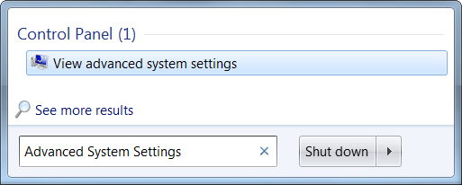

Click the Settings button under performance.

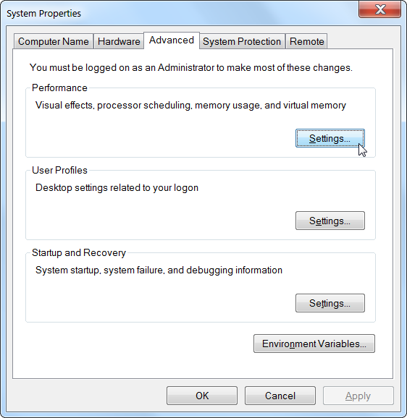

Click over to the Advanced tab and click the Change button in the Virtual memory section.

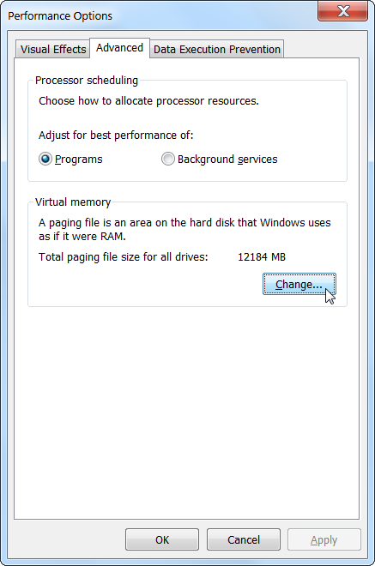

Windows automatically manages your page file settings by default. Most users should leave these settings alone and allow Windows to make the best decision for you.

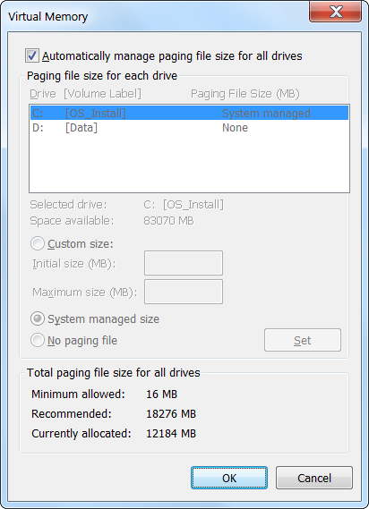

However, one tweak that may help in some situations is moving the page file to another drive. If you have two separate hard drives in your computer, assuming one is the system drive with your programs installed on it and one is a less-used data drive, moving the page file to the data drive can potentially offer some increased performance when your page file is in-use. Assuming that Windows will already be using the system drive if it needs to use the page file, this spreads out the hard drive activity instead of concentrating it on one drive.

Note that this will only help if you actually have two separate hard drives in your computer. If you have one hard drive separated into multiple partitions, each with their own drive letter, this won’t do anything. Whether it’s partitioned or not, it’s still the same physical hard drive.

In summary, the page file is an essential part of Windows. Even if it’s rarely used, it’s important to have it available for situations where programs are using an unusually large amount of memory.

Having a page file won’t slow down your computer – but if your computer is using its page file a lot, you should probably get some more RAM.